**USING RAPTOR – CALCULATE FIBONACCI SERIES**

**A.V Bhargava(1191911110)**

**FLOWCHART**

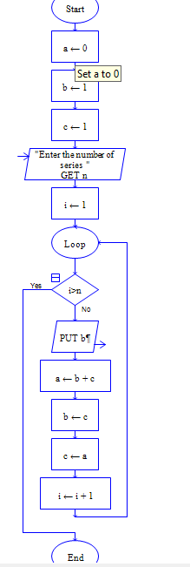

**OUTPUT**

INPUT IS 9

